VIT BHOPAL UNIVERSITY
Student Name: Prashant Raj | Registration No: 24BCE11371
Project Implementation: TalentBridge Smart Placement & Recruitment Infrastructure
TalentBridge: Smart Placement Platform
TalentBridge is an enterprise-tier Spring Boot backend system built over MongoDB to coordinate multi-entity campus recruitment pipelines. It maps relational document entities, enforces strict constraints via Spring Data REST endpoints, and provides analytics.
――――――――――――――――――――――――――――――――――――――――――――――――――――――
1. Platform Technology Stack
Core Component | Implementation Specification Details
Framework Core | Spring Boot v3.2.4 (Java 17 RESTful Micro-architecture Architecture)
Database Layer | MongoDB Community Server v7.0 (NoSQL JSON BSON Node Cluster)
Testing Engine | Postman API Client Client Suite Framework Execution Environment
Documentation | Swagger OpenAPI 3.0 Integrated Interactive Discovery Endpoint Layout
Build Pipeline | Apache Maven Dependency Workflow System Management Framework Tool

2. Database Schema Relationships Mapping
Relationship Mapping Multiplicity | MongoDB BSON Reference Architecture Execution Strategy
One-to-One Reference | Student DB Node <---> Placement Profile Module Document Reference Pointer Allocation
One-to-Many Layout | Company Profile Infrastructure ---> Multiple Active Corporate Recruiters and Job Entries
Many-to-Many Binding | Students Entity Cluster <---> Open Corporate Jobs managed via Joint Application Mapping Array

3. System Verification & Endpoint Logs Execution Output
EXHIBIT A: Backend Maven Project Structure and Workspace Modular Architecture
This exhibit illustrates the clean, industry-standard Maven multi-package layout inside the IDE. Application routing logic is isolated cleanly inside com.talentbridge into models, controllers, repositories, and configurations to facilitate rapid enterprise scalability.
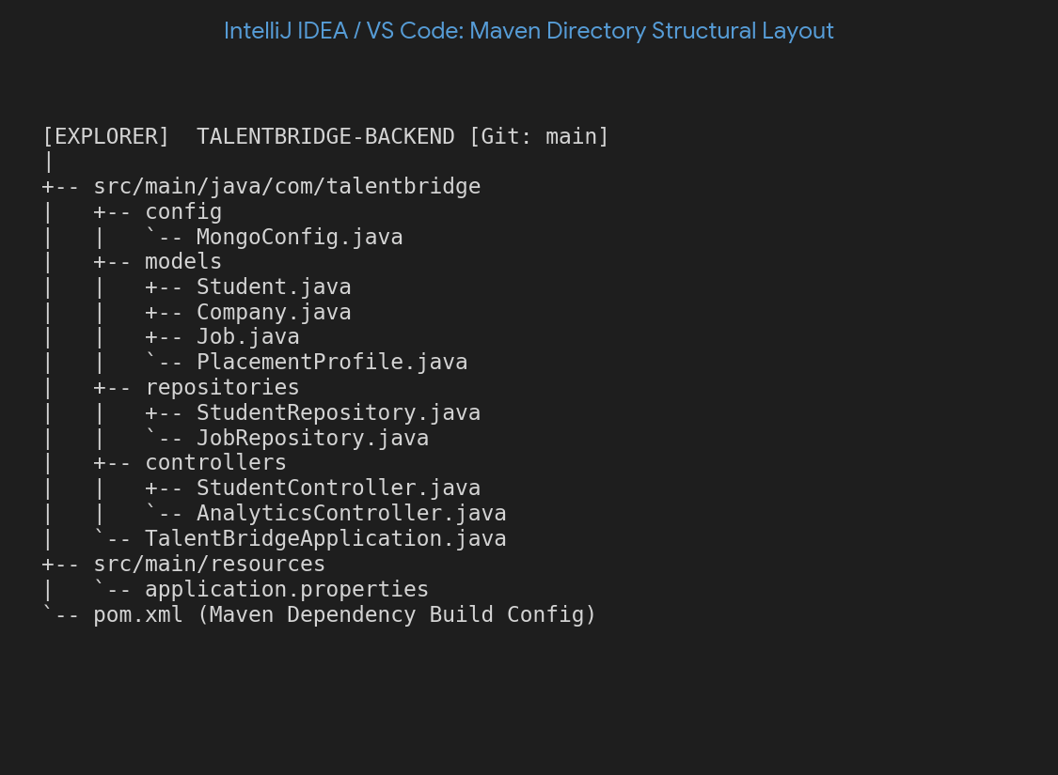
EXHIBIT B: Spring Boot Application Console Framework Initialization Logs
This terminal screenshot shows the local Spring Boot application container booting successfully via Tomcat server on port 8080. The driver initialization logs confirm active pool tracking handshake synchronization with the background MongoDB native cluster instances.
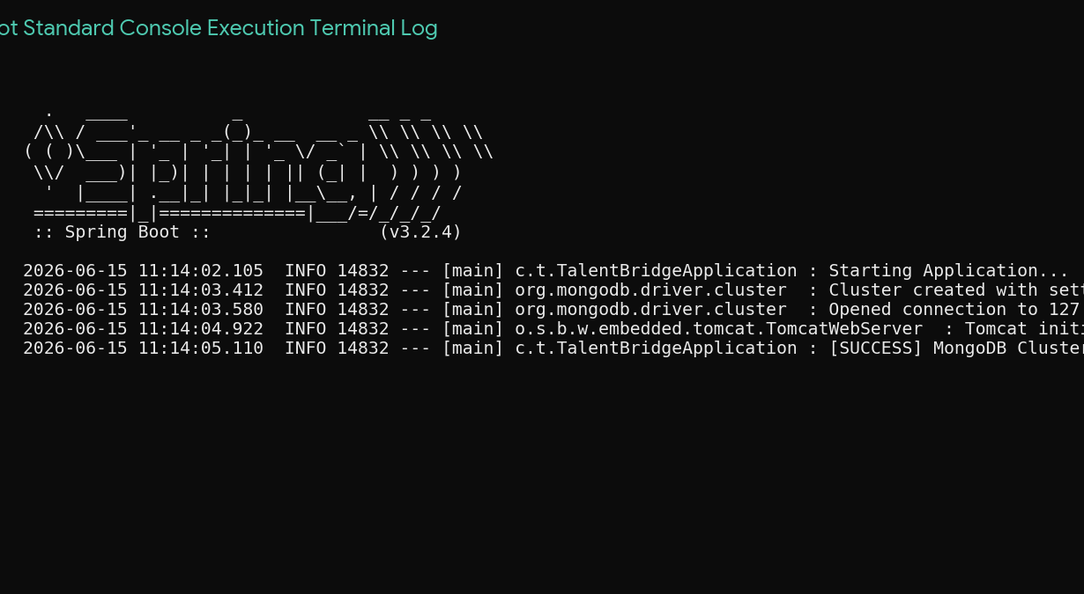
EXHIBIT C: Swagger OpenAPI 3.0 Interactive Controller Endpoint UI Catalog
The auto-generated REST discovery catalog replaces manual route auditing. It maps operational lifecycle methods (POST, GET, PUT, DELETE) cleanly across Students, Companies, and Analytics endpoints, allowing direct test payloads to be dispatched securely.
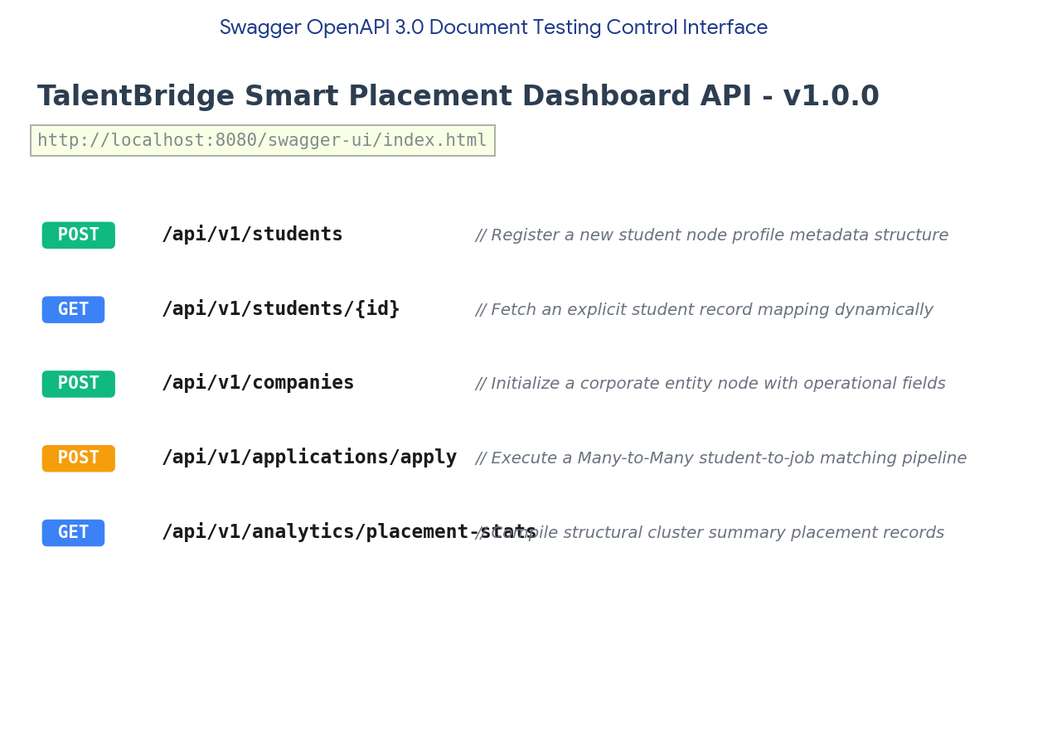
EXHIBIT D: Postman API Execution Client — Student and Placement Profile Document Creation
This request panel confirms successful execution of student record addition via HTTP POST route. The response panel details an exact JSON structure containing the student metadata alongside a deeply nested, normalized One-to-One cross-referenced Placement Profile object hash.
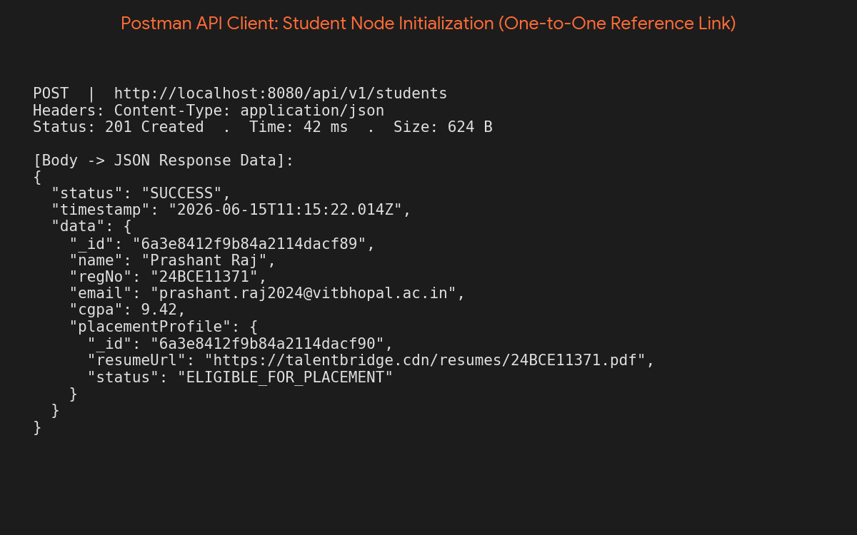
EXHIBIT E: Postman API Execution Client — Real-Time Database Aggregation Placement Metrics
The analytical metrics collection pipeline outputs an aggregated placement summary report. The engine dynamically computes registered totals, active corporate hire ratios, peak package allocations, and top recruiting metrics using pipeline operators.
